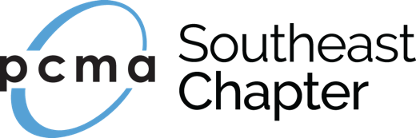
PCMA Southeast Chapter
Board of Directors Position Description
Position Title: Director of Sponsorship
Reports to: Chapter President

POSITION SUMMARY:
The Director of Sponsorship is responsible for promoting opportunities, outreach, and securing of the Chapter’s marketing and events’ sponsors. This position is responsible for leading the chapter’s Sponsorship Committee of Volunteers on all sponsorship initiatives of the PCMA SE Chapter.

Statement of Purpose: Securing sponsors for Chapter

ESSENTIAL DUTIES AND RESPONSIBILITIES:
Board & Leadership
- Accordance with all bylaws and policies mandated by Chapter and PCMA National
- Attend and participate in monthly board meetings, which are conference call and in-person throughout the year
- Attend and participate in an annual board retreat (typically Thursday – Saturday)
- Organize, manage and lead a committee of volunteers
- Accountability for tracking and execution of operational tasks relating to position
- Support initiatives and programs held by the chapter
- Manage budget for any associated costs for Chapter’s sponsors
- Create a succession plan and train successor toward end of term

Sponsorship Sales
- Secure CVB and Supplier sponsors for four (4) quarterly educational programs
- Secure sponsors for Spring and Fall Community Service programs
- Secure sponsorships for annual Social Event
- Secure sponsors for Convening Leaders Chapter Reception
- Secure website and e-newsletter sponsors
- Assist with securing sponsors for up to four (4) satellite meeting per year; work with Past President
- Secure annual Volunteer of the Year Sponsor
- Secure annual Planner Recruitment Sponsor
- Secure annual Past Presidents Circle Sponsor
- Monitor sponsorship fulfillment requirements, communicate deadlines, and ensure all are met
- Obtain logos from current sponsors and ensure proper logo placement for duration of sponsorship
- Assign tasks to committee members and schedule quarterly (or more, if needed) conference calls
- Obtain signed sponsorship agreement form from each sponsor and submit to Chapter Admin
- Create and/or work with potential sponsors on new ideas for sponsorship opportunities

Website, Social Media & Online Community Management
- Write and submit sponsor information for Chapter News on website and subsequent newsletter
- Assist with social media postings to generate sponsorship interest

KNOWLEDGE, SKILLS, AND ABILITIES:
- Knowledgeable of PCMA
- Ability to outline needs, target prospects, and effectively engage membership for sponsorship participation
- Ability to work in a fast-paced environment and meet deadlines
- Ability to work on own and delegate tasks
- An excellent, open, articulate, and personable communicator with diplomatic and persuasive communication skills
- Proficient in MS Office (Word, Excel, PowerPoint)

PHYSICAL REQUIREMENTS AND ENVIRONMENTAL CONDITIONS:
- Ability to perform work utilizing a computer for extended periods of time
- Ability to sit for extended periods of time in performing work
- Ability to travel by air or ground transportation as required in performing the work and abilities as described to perform the job on a consistent basis.

