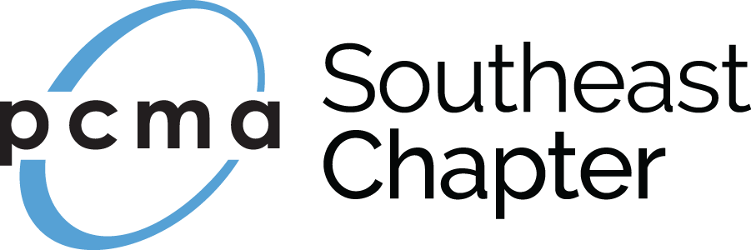

2018 Convening Leaders Scholarship Application
Send your completed application to:
Attn: Kevin Belanger
Shepard Exposition Services
1531 Carroll Drive, NW
Atlanta, GA 30318
Phone: 678-410-5565
e-mail: kbelanger@shepardes.com (Please submit electronically if possible)

2018 Convening Leaders - Nashville, TN, January 7-10, 2018
Application Deadline is August 31, 2017

Personal Information:

Name: _____________________________________ Title: ________________________

Organization: _____________________________________________________________

Address: _________________________________________________________________

City: __________________________ State: _________________ Zip: _______________

Phone: ______________________________ Email: ______________________________

Supervisor name and title (if applicable) ________________________________________

- Planner Supplier

PCMA SE Chapter Experience:

- Number of years in the Meeting Industry ____________ (x1 point per year)=______
- Number of years as a PCMA/PCMA SE member ________(x2 points each)=________
- Chapter Officer - # of terms ______________________(x10 points each)=_______
- Board Member - # of terms ______________________(x8 points each)=_________
- Committee Chair - # of terms ____________________(x6 points each)=_________
- Committee Member - # of terms __________________ (x4 points each)=________
- International Committee Member, Chair or Officer (x3 points each)=_____________

TOTAL OF POINTS FOR APPLICANT__________________________________

Have you ever received a PCMA SE Scholarship in the past? Yes _______ No ________

If yes, when and for what reason?

Please list any other information that you would like for the Scholarship Committee to consider:

_________________________________________________________________________

Name/Signature and Date

By submitting this application, I agree to the following policies pertaining to the scholarship. I also agree that if I am awarded the scholarship and for some reason I am unable to attend I will immediately notify Kevin Belanger at (678) 410-5565.

- The recipient must be a PCMA SE member of good standing.
- The recipient agrees to submit required registration information to the PCMA SE Chapter Administrator no later than October 27, 2017.
- The attendee or employer must agree to pay any additional costs incurred for the conference attendance.
- Recipient commits to planning on attending the entire conference.
- The recipient must agree to submit an article to the Director of Communications for the PCMA SE Chapter Newsletter about an educational session attended and/or the experience of attending the conference within 30 days of attending the conference.

